# Step 1 You need a free AWS account

<https://aws.amazon.com/>

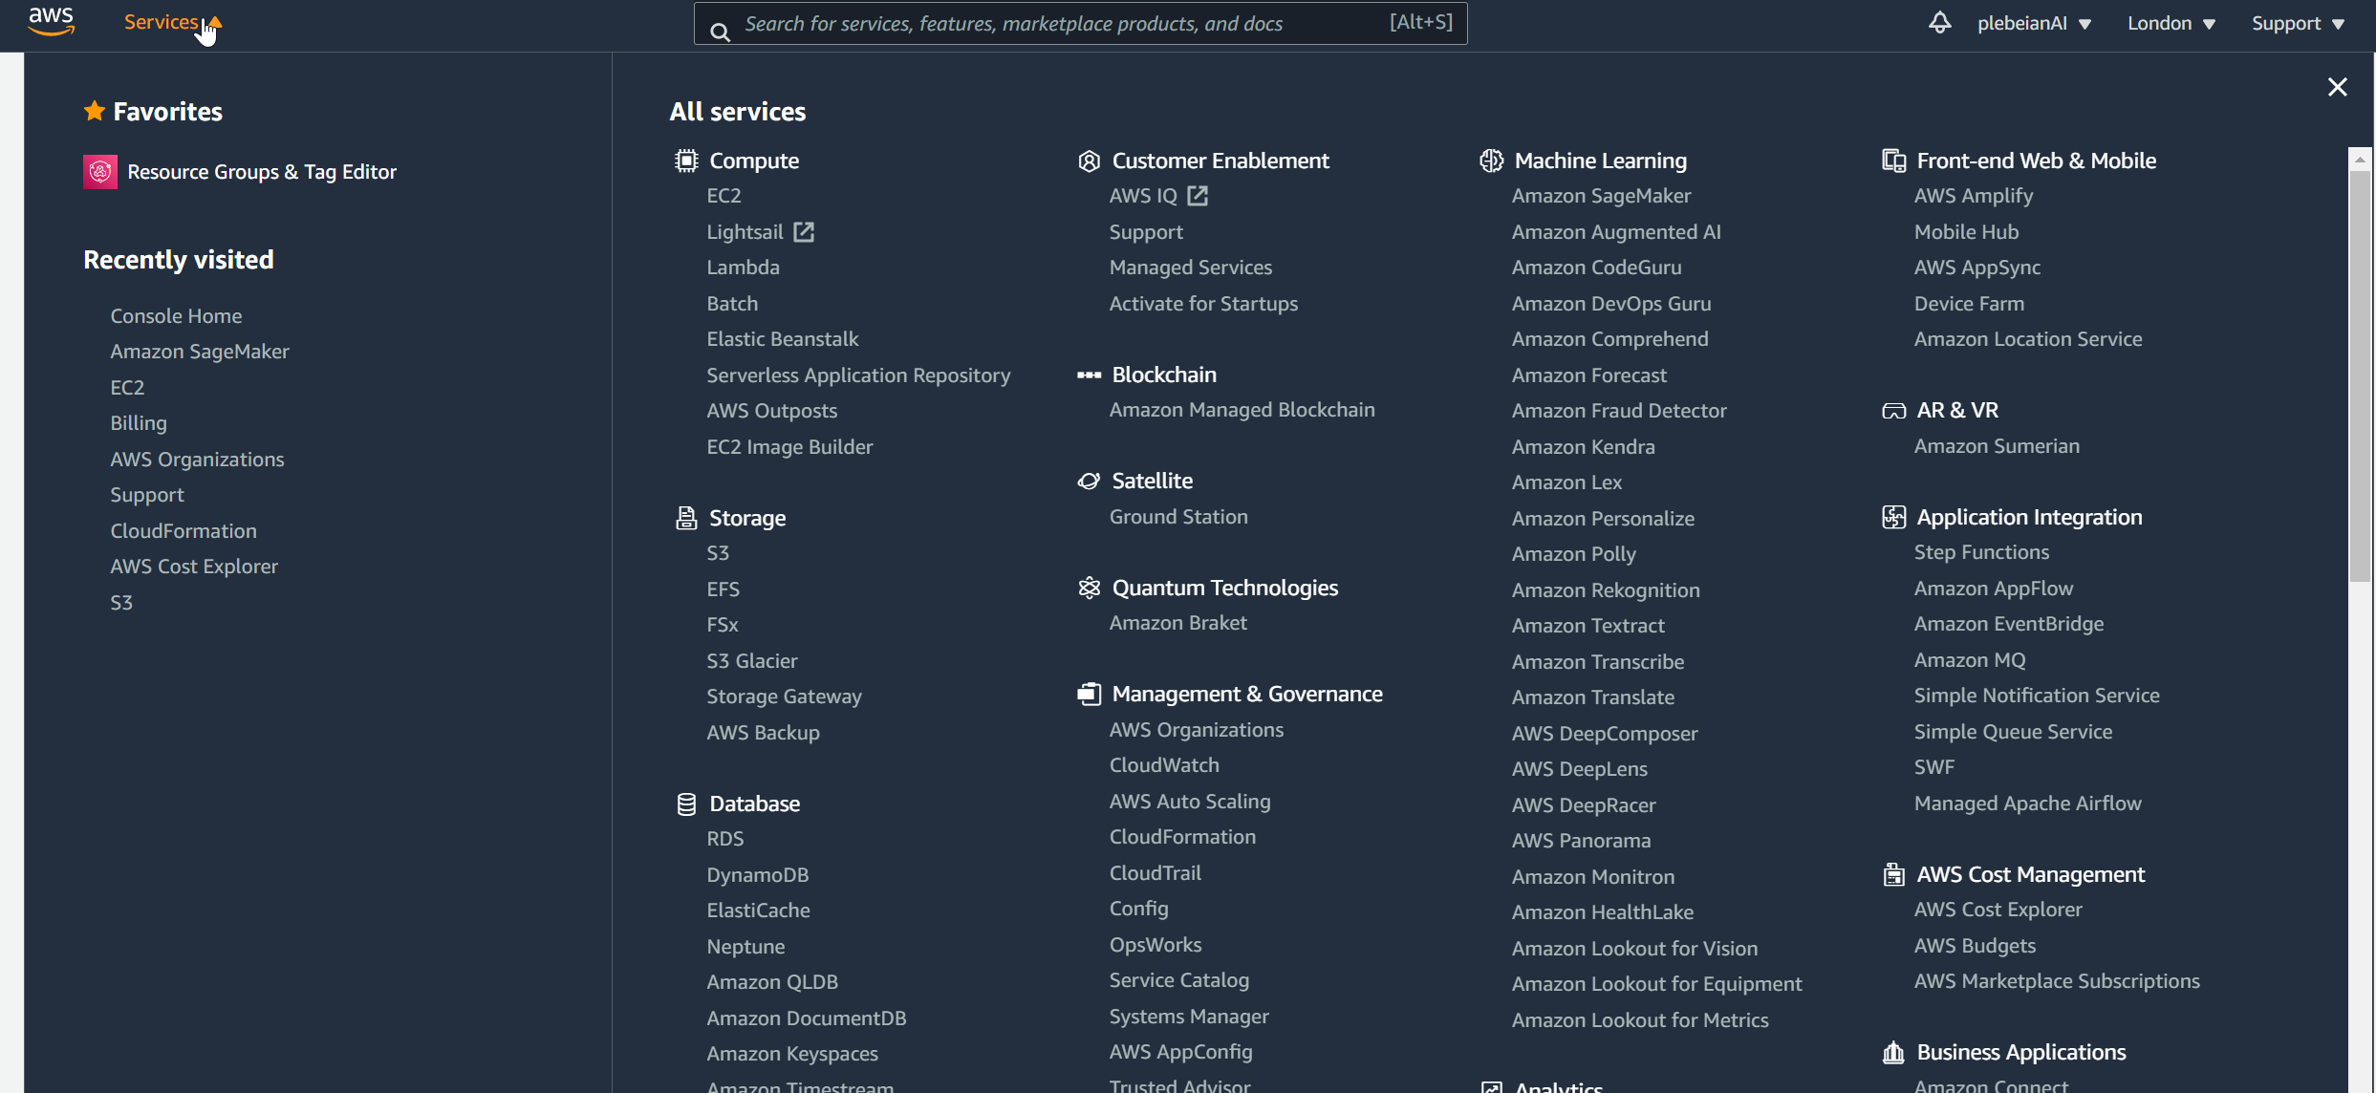

Step 2 You need a "machine image" - basically an operating system and RStudio server. You can do this the "hard way" (install or rent your own OS) or the "easy way" (find an image someone else has made).

[We will use one from these resources by Louis Aslett.](https://www.louisaslett.com/RStudio_AMI/)

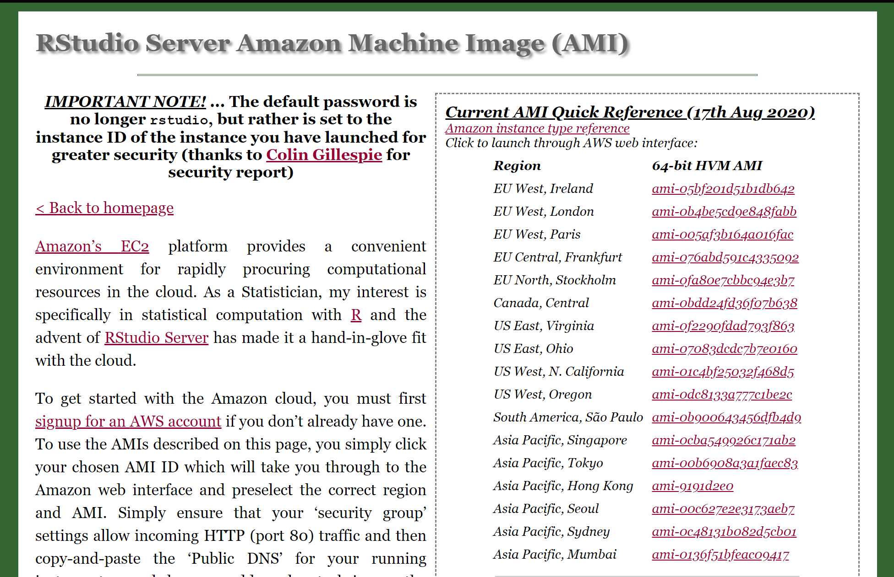

# Step 3 Pick an AMI config near you

This will take you to the Amazon config page for your account to set up the instance

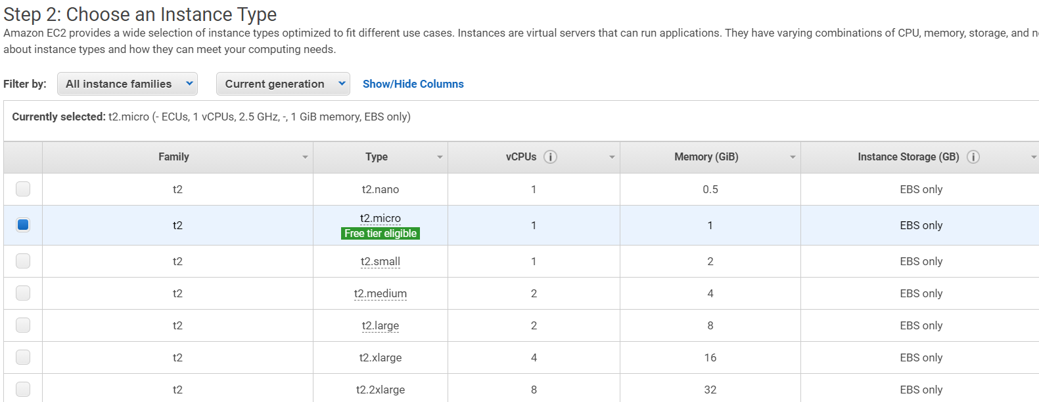

References https://towardsdatascience.com/how-to-run-rstudio-on-aws-in-under-3-minutes-for-free-65f8d0b6ccda

# Step 4 Configure the instance

For this test we will stay with the defaults, EXCEPT that I want to enable access to my RStudio server from web pages for myself and others. We need to add detail on the "Step 6" security settings page. We leave the default SSH security group (we can control the server with this via the command line in Linux); we want to add an HTTP method.

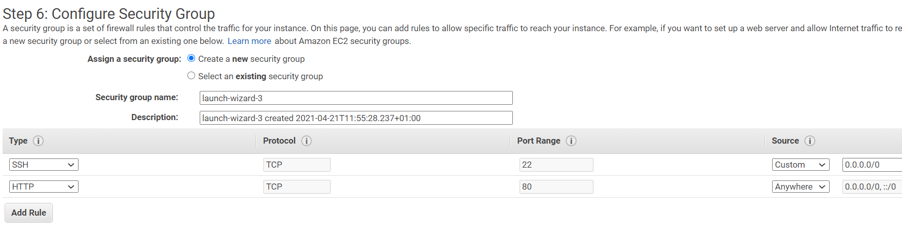

Step 5 Click review and launch on the Step 6 page, then launch on the Step 7 page

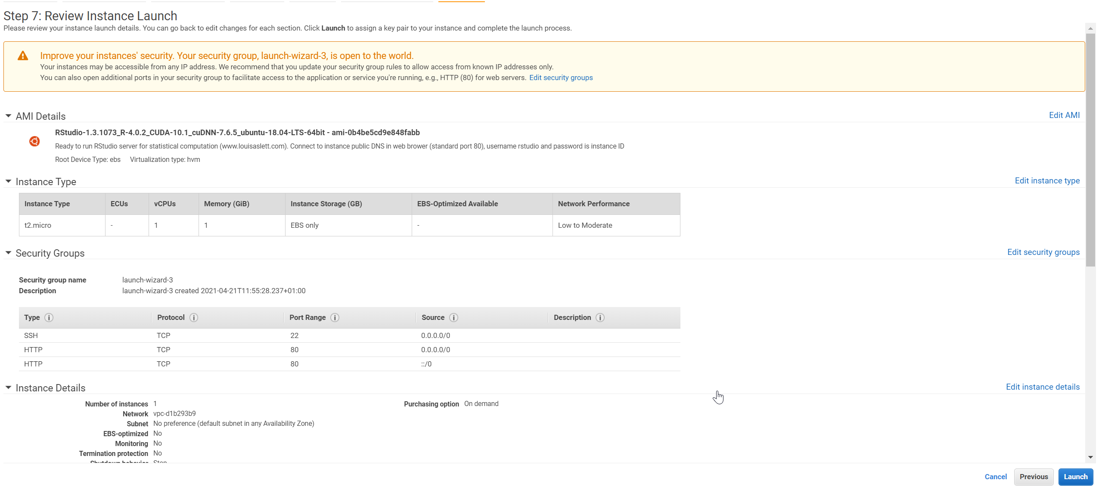

Step 6 Create and download a new **security authentication key pair** - this is a file that confirms your identity as the admin for your server instance.

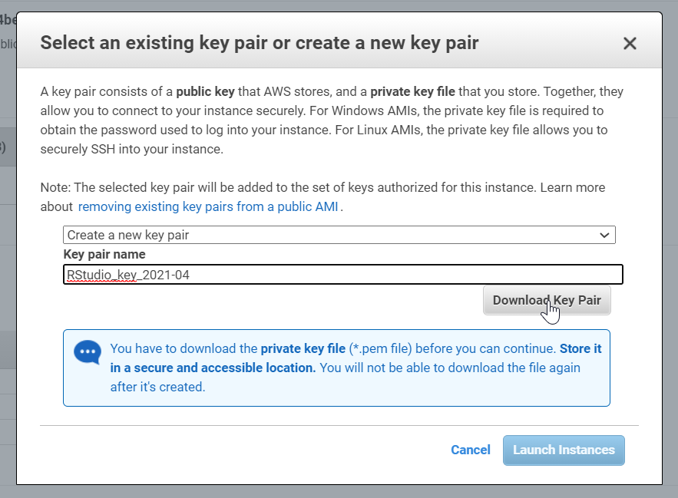

Step 7 Check your instance is running

Woot

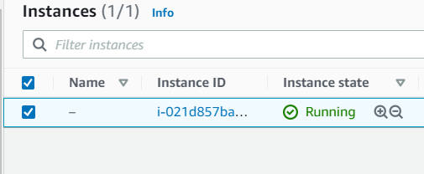

# Step 8 Log in via webpage

The IP address is your instance IP address

The default username is <rstudio>

The default password is your AWS AMI Instance ID

After you log in to test the environment, you can log right back out

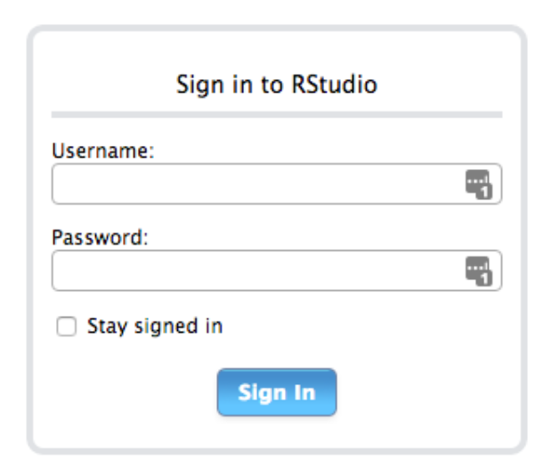

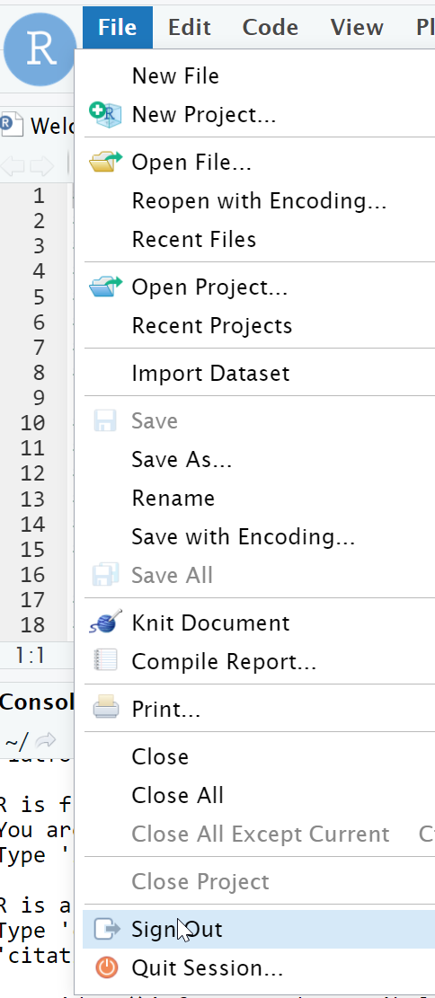

# Step 9 Set up the RStudio environment on the server

We typically would do this with command line tools using an SSH client. This might be installed by default and available via a console program. I just used the default Terminal app built right into RStudio Server.

***

sudo adduser name-surname

Default password: rafisher

All other fields blank

Users:

joe-roberts

# Activities

# 1 Set up accounts and have people log in. Successfully…

# 2 Change your password

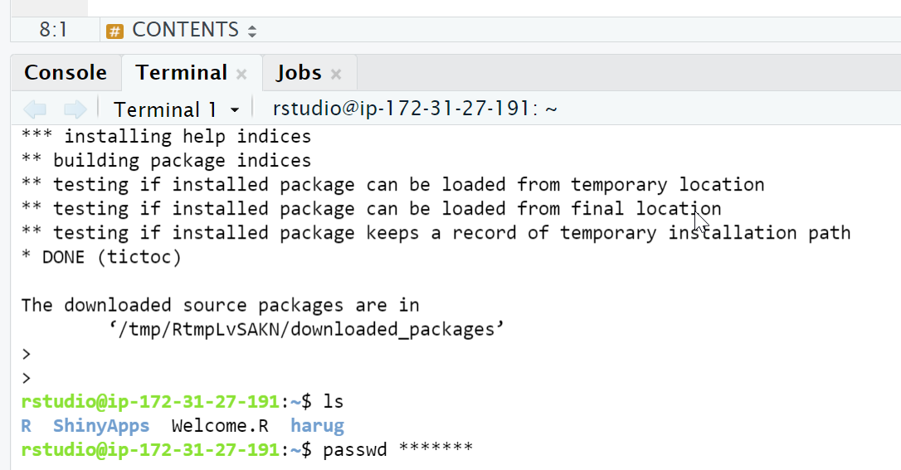

3 Upload the zip folder with a data set and script

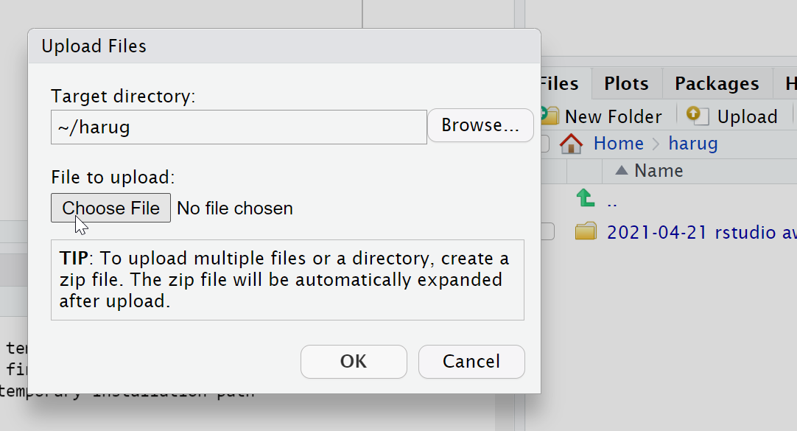

# 4 Open the script aws.R

# 5 Packages

Test 1: is package {tictoc} available locally or must it be installed? What about the {randomForest} package?

# 6 Several users working

- read in dormouse.csv

- examine the data

- make any graph

- we can show a few graphs

# 7 Speed test on default server

Run tic() toc() code

# 8 Repeat speed test on BEEFIER server if there is time

Run tic() toc() code